Payment Services

Use Message Broker to communicate with Payment service

Date : 11/1/2020

**Status** : Proposed

**Context** : Payment service is used for calling external payment gateway . Once order is placed order service should call to payment service . According to the event driven microservice concept each service is responsible to one bounded context and need to independent . Therefore Message broker is used to decouple services and communicate with each other .

There is a need of having a Message broker for communication with Payment Service .

Options are RabbitMQ, Aws SNS, AWS SQS , Apache Kafka

Architectural characteristic that required :

* Scalability
* Reliability
* Maintainability
* Deployability

**Decision**: Use RabbitMQ

**Consequences** : AWS SQS , SNS cannot be used at on-premise deployments . RabbitMQ and Apache Kafka both good at on premise deployments and both are open source but RabbitMQ is lightweight and easy to use than Apache Kafka

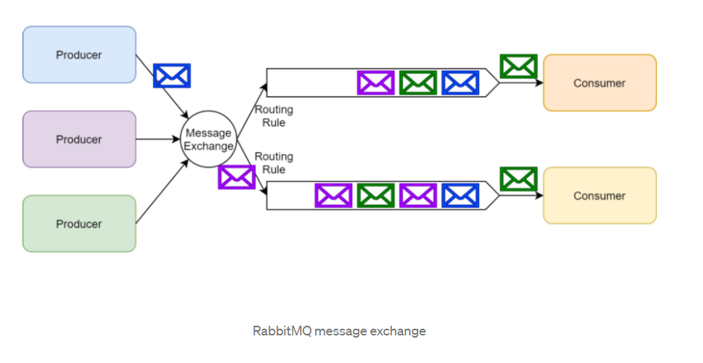

(2) PayPal as the payment gateway

Date 11/1/2020

Status : Proposed

Context :

There is a need of having Payment Gateway .

Architectural characteristic that required

* + Security
  + Reliability
  + Simplicity

There are options like

* Payza
* PayPal
* Amazon Pay

Decision :

Use PayPal

Consequences :

Payment gateway integration is a third party integration so support from external party is important and PayPal support is good . PayPal Provides Following Features And PayPal is well tested with reliable .

* PCI Compliance
* Express Checkout
* Shopping Cart
* Barcode Scanning
* Credit card reader